**透過Kubernetes強大管理容器功能**

**Data Service Server協助中小企業快速部署輕量級私有雲方案**

**Data Service Server Helps SME Accelerate Cloud Deployment**

Light Private Cloud Solution Leveraging Powerful Kubernetes Containerized Management

雲端已成為各類智慧化應用的重要架構，透過雲端，企業可大幅提升系統的部署速度與彈性，過去多數中小企業因成本考量，大多使用公有雲，不過部分領域業者像是半導體製造、CNC機台等業者，在場域限制、資料敏感或網路安全…等因素下，傾向建置私有雲，不過由於市場上的私有雲多為大型企業設計，此類系統的架構龐大，且需投入大量資金，對中小企業來說難以負荷，對此研華近期推出輕量版Data Service Server解決方案，此一解決方案結合研華的硬體設備與設備營運管理WISE-PaaS/DeviceOn，提供資料蒐集、管理與呈現等功能，並具備高可擴充性的完整微服務架構，中小企業可以評估資源與需求後選擇服務，建構出合身的私有雲系統。

Today, great volumes and varieties of intelligent applications are implemented on cloud platforms which help the enterprises improve system deployment speed and flexibility. Many small and mid-size enterprises (SME) have chosen to use public clouds out of considerations over cost. But enterprises in certain industries like semiconductor and CNC manufacturing have deeper concerns over data sensitivity, internet security and site restrictions, and they prefer private cloud. However, most private cloud products are designed for large businesses, with mammoth architecture and huge investment required, which are unaffordable for medium and small businesses. To address the smaller businesses’ needs for private cloud, Advantech Technology has recently rolled out a light private cloud solution Data Service Server, an all-in-one solution incorporating Advantech hardware and IoT device operation management software WISE-PaaS/DeviceOn to provide data collection, management, visualization and other on-demand micro-services, with high system scalability. The SME customers may assess their resources and choose feasible services to organize their own private cloud system that will fit their needs and their budgets.

**段標：Kubernetes與Windows各有所長**

**Both the Kubernetes and the Windows have advantages in their own ways**

為了強化彈性擴充功能，研華在Data Service Server中設計出Kubernetes與Windows Server兩種架構。Kubernetes常簡稱為K8s，是目前Linux中最常用的容器管理架構。傳統資料中心常因架構不同，導致同一資料必須經過二次開發，才能讓資料在另一架構上運作，讓系統調配管理失去彈性。容器管理則是可以快速搬移資料，例如製造業者要將公有雲上的資料移轉到不同架構的私有雲，容器管理架構會是最有效的方式。這就像是智慧手機應用程式，由於iOS、Android兩大系統並不相容，開發人員必須針對這兩大陣營設計不同版本的程式，容器管理則是只要透過單一管理架構，就可以將資料搬移到不同架構中，設計團隊只要開發一次，就可讓資料在不同架構中使用，藉此縮短系統開發時間並且大幅提升其運作彈性。

To boost flexibility and scalability, Advantech has designed a binary architecture for its Data Service Server which supports both the Linux-based Kubernetes and Windows Server operating environments. The Kubernetes, also known for its short form “k8s”, is currently the most prevalent container management architecture for Linux. It was created to address the shortfalls of traditional architecture for data centers in terms of system relocation flexibility; the traditional architecture requires for a second development to migrate the same data loads to another platform, while the k8s is an open source platform for managing containerized workloads which can be moved to anywhere quickly and conveniently. For example, if a manufacturer wants to move their company’s data from a public cloud platform to a private cloud of different architecture, containerized management will be the most efficient way.

It is just like, for example, that app developers traditionally have to develop different versions of programs respectively for the iOS and Android mobile platforms incompatible to each other, while with containerized management now they can simply move their data containers to another platform for reuse, without the need to redevelop programs. The k8s helps a lot in shortening system development time and increasing operational flexibility.

Windows Server架構的好處則是簡單、易用，不必做二次開發，就可使用研華WISE-PaaS/DeviceOn的各種服務

。在此一架構下，即便內部沒有開發團隊的中小型製造業，也可透過Data Service Server的簡易使用介面與研華專業技術支援團隊，快速建立起設備聯網管理系統，讓系統中的資料可以快速嫁接、管理，並以視覺化方式呈現數據內容。

The Windows Server architecture, on the other hand, is simple and easy to use, on which the users may utilize all kinds of services of Advantage WISE-PaaS/DeviceOn directly without extra development efforts. Therefore, even small and medium-sized businesses which do not have a strong in-house team of developers can build up their management system for their connected equipment to integrate, manage and visualize their data by themselves, which can be done within short time via the simple and easy-to-use interface provided by Advantech Data Service Server with Advantech technical support.

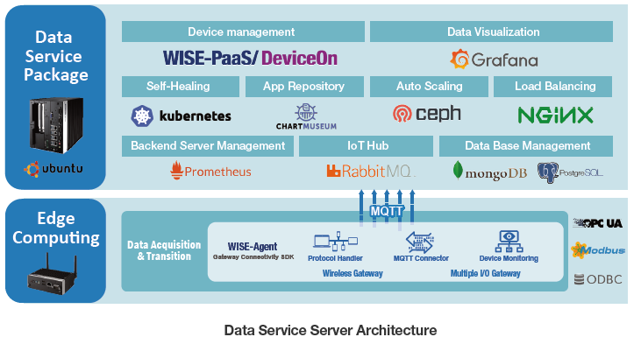

分析這兩者的使用差異，由於Kubernetes目前主要支援Linux系統，因此在研華的Data Service Server是運行於Ubuntu上。Windows Server自然是以原有的Windows Server 2016系統為主。擴展性部分，Kubernetes只要透過硬體新增，就可以動態擴容讓原有系統的效能在新增設備上無縫延伸；Windows Server則是只能單機運行WISE-PaaS/DeviceOn。應用架構上，Kubernetes微服務特色，可以讓同一服務應用在不同架構上，讓系統有較高彈性。至於AI平台的應用，Windows Server受限於現有機器學習工具選擇性較少，而Kubernetes 中的Kubeflow可以支援多種開源軟體，例如Tensor flow, Caffe等深度學習平台，都是市場上研發團隊選擇Kubernetes做為人工智慧開發架構的主因。

Analyzing the differences between the two versions in practice, we can see that the Advantech Data Service Server for Kubernetes runs on the Ubuntu OS issued by Linux, while the Windows Server mainly on Windows Server 2016. In terms of expansion, users of Kubernetes only have to increase hardware to extend the original system performance seamlessly; while the Windows Server can run WISE-PaaS/DeviceOn only on standalone system. In terms of application architecture, the Kubernetes allows a same micro-service to be implemented on different architectural platforms and therefore has higher system flexibility.

As for the application of AI platform, the Window Server has fewer options of tools for machine learning, while the Kubernetes’s machine learning platform Kuberflow supports various open source software—such as Tensor flow and Caffe, which is the main reason why most AI developers prefer Kubernetes for AI development environment.

私有雲雖然可以將資料留在企業內部，降低外洩的可能性，不過對企業來說，私有雲的建構並不容易，除了需要投資大量資金購入硬體設備外，還要在內部成立IT團隊，專職開發、維護系統，此外系統的開發時間常難以正確預估，上線後的功能也需要經過一段時間的調整，才能真正貼合現場人員使用，對資源有限的中小型製造業來說，私有雲所需的資金、人力、時間，都會對企業帶來沉重負荷。Windows Server版本的Data Service Server則是整合了完整WISE-PaaS/DeviceOn功能的私有雲解決方案，中小企業僅需要1～2人的極少量人力，就可以快速建置出貼合需求的私有雲平台。

Though private cloud keeps data within the inside of the enterprise and reduces the possibility of data leak, it is not easy for an enterprise to construct a private cloud. In addition to huge investment on hardware equipment, it also requires for the establishment of an IT team specialized in developing and maintaining the system. Besides, it is difficult to assess the length of time needed for completing system development precisely, and after the system goes online it will require another period of time for adjustments to truly fit the needs of field users. For medium-and-small sized manufacturers whose resources are comparatively restricted, the capital, manpower and time required for developing a private cloud will pose heavy burden on them.

Addressing the needs of the SME, the Windows Server version of Advantech Data Service Server is a private cloud solution integrating complete WISE-PaaS/DeviceOn functions, which will require for only one or two persons in the medium or small enterprises to quickly construct a private cloud platform fitting their company’s own needs.

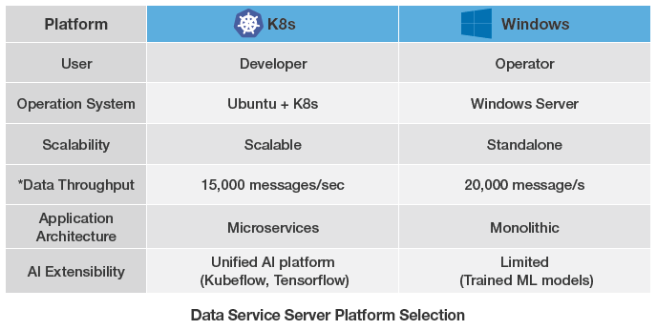

**段標：建置K8S各種服務 研華Data Service Server功能完整**

**The Advantech Data Service Server is well-prepared for building k8s functions**

相較於目前市場上的私有雲解決方案，研華的Data Service Server在平台管理、設備管理與應用方面都有其優勢。在平台管理方面，Data Service Server的容器管理機制具有獨立開發管理特色，IT人員可以針對不同容器隨時調整、更新版本，解決了之前修正程式時，整體架構必須同步更動的問題。

Compared to competing products of private cloud solutions in the market, the Advantech Data Service Server delivers more advantages in platform management, device management and applications. In terms of platform management, the containerized management mechanism of Data Service Server features independent development and management, which allows IT persons to adjust different containers and renew versions at any time, without the need to change the overall structure when making changes to programs as in traditional practices.

傳統的雲端平台管理是在作業系統上加入虛擬機器，再於其上運作應用程式，在此一系統環境中，資料與應用程式的搬移會受侷限，容器管理機制則是每一應用程式包裝為獨立環境，在此一環境中，容器的所有資料都被儲存在標準化平台Docker的映像檔(Image)中，無論是Windows或Linux，只要支援Docker標準的系統，都可藉由此映像檔重建相同的容器，執行相同應程式。

The traditional cloud platform management is to add virtual machines to the operating system for running programs, but under this environment the migration of data and programs will be limited. While the containerized management packs each application program into an independent environment, where all container data is stored in standardized Docker Image files. In this way, any system, no matter running on Windows or Linux, may reconstruct same containers via the Image files to execute the same programs as long as the system supports Docker.

在Docker作法上，Kubernetes再針對容器管理做了進一步的優化與加值服務。例如在某應用中，需要使用三個影像檔執行單一工作時，在Docker體系下是用Docker-Compose連結各容器再執行，而相較於Docker-Compose，Kubernetes則納入了更多資源，可將容器內的應用做一體化自動管理，例如當系統內容器的負載超過預設值，Kubernetes就會會自動增加容器數量，而如果所管理的應用程式停擺，Kubernetes也會自動重啟該程式，讓系統恢復正常運作，藉此強化系統的擴充性與穩定性。

On the base of Docker, the kubernetes takes s step further to optimize containerized management and add valued services. For example, if an application requires three Docker Image files for executing a task, a conventional Docker system will use Docker-Compose to connect all containers for implementing the task, while the kubernetes will put in more resources to implement automated management over the containers in the application—such as adding containers automatically to the application once the container loads reach preset shredshold, or automatically restarting application programs if the programs break down, so as to resume system operation. In these ways, the kubernetes enhances system scalability and reliability.

要滿足外部需求，除了增加容器數量外，儲存空間也必須同步擴充。針對此問題，Windows Server由於在導入時就綁定主機與硬碟，因此擴充並不容易。對此研華的Data Service Server導入了Ceph RBD (Ceph’s RADOS Block Devices) 檔案系統管理機制，此機制讓後端每一儲存空間都各自虛擬化，再透過Kubernetes統一管理這些不同的虛擬空間，並因應前端容器數量與其儲存需求，快速自動調配儲存空間，此一方式解決了過去儲存空間不足時，必須停機安裝新硬碟所導致的運作延遲問題。

To satisfy external needs, system storage capacity has to be expanded as well to accommodate the increased number of containers--which is more difficult for the Windows Server architecture, as usually the Windows OS has been bound to its registered main board and hard drive since it was first installed. To solve the problem, Advantech has preinstalled a Ceph RBD (Ceph’s RADOS Block Devices) file system management mechanism in its Data Service Server, which will virtualize each storage space at the back end and allow Kubernetes to automatically manage all these virtualized spaces in response to the needs at the front end for containers in number and capacity. This Advantech approach reduces the downtime of system for installing a new hard disk when storage capacity runs out, compared to the traditional practices of Windows Server that often has to cease the system for a longer time for reinstalling major components.

除了容器管理與儲存空間的管理優化外，研華的Data Service Server還搭載了Kubernetes的Prometheus後端監控與Grafana數據視覺化兩大功能。Prometheus可蒐集、監控平台上各種應用、資料中心、電腦叢集的數據與使用量，並在儲存空間即將不足或軟硬體功能停擺等特定情況發生時，向管理人員發出警報。Prometheus蒐集各種數據後，會將之傳送到Grafana上，Grafana會將數據轉化為各種視覺化圖表，特別一提的是，除了系統內各電腦叢集的數據外，DeviceOn系統所管理的各種外部設備資訊，也可以呈現在Grafana視覺平台上，讓管理者可以跨系統掌控所有資訊。

In addition to optimized management of containers and storage capacity, the Advantech Data Service Server is also built-in with crown jewels of Kubernetes functions—Prometheus for backend monitoring control and Grafana for data visualization. The Prometheus collects and monitors data of applications, data centers and computer clusters, and will alert system administrators on situations such as storage capacity insufficiency or hard-or-software malfunctions. The data collected by Prometheus will be sent to Grafana for transforming into various tables and figures for visualized display. Notably, in addition to computer cluster data, data of various external devices under the management of DeviceOn also can be displayed on Grafana to allow the users to get all cross-system information in hand.

另外在應用管理方面，Data Service Server也建置了CHARTMUSEUM，為了免於開發時每次都要搭建全新環境並手動配置物件，現在開發者多會使用Helm，CHARTMUSEUM就是可支援各種主流Kubernetes環境與服務的Helm儲存工具，開發者可以存放各種常用程式，藉此快速部署Kubernetes系統。另外這幾年AI逐漸為各類系統所採用，在AI開發平台部分，Data Service Server則有Kubeflow，提供廠商機器學習演算法的開發平台，為接下來的各種AI應用做準備。

For the management of applications, the Advantech Data Service Server is also built- in with Kubernetes-supported CHARTMUSEUM function to allow the developer to build their own repository of programs for reuse in another development project, so that the developers will not have to start from scratch and move their objects manually each time when they begin a new project. This function will help to accelerate deployment of Kubernetes systems. Besides, when AI becomes a more crucial part of all kinds of system in recent years, the Data Service Server provides Kubeflow AI development platform for customers to develop their machine learning algorisms in preparation for all kinds of AI implementations.

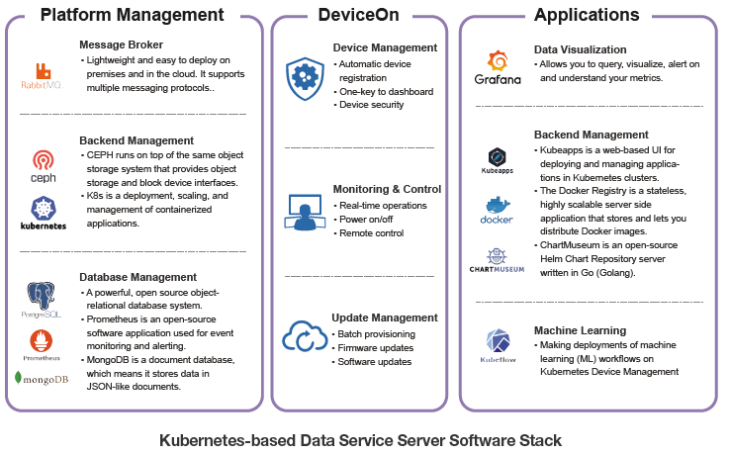

**段標：WISE-PaaS/DeviceOn讓設備管理更有效率**

**The WISE-PaaS/DeviceOn provides more efficient device management**

在Data Service Server 上搭載了研華專門為工業應用的所開發的App，WISE-PaaS/DeviceOn，配合上Kubernetes系統的服務都讓研華的WISE-PaaS/DeviceOn平台的設備維運、資料蒐集與視覺化呈現等三大功能運作更具效率。工業設備早已成為各領域的核心營運工具，像是製造系統中的各類自動化機械、零售店面的POS與Digital Signage、風力發電的監控平台…等，在這些領域的運作體系中，這些工業設備不僅數量龐大，而且常常是散置於各處，這往往造成管理上的困境，過去仍沒有聯網技術時，常會有維修人員到現場巡查，才發現該處設備已經故障多時的狀況，而即便是現在已經聯網，人員也必須花費時間長途來回才能完成檢修工作。

The Data Service Server is preinstalled with WISE-PaaS/DeviceOn, an IoT enabler designed by Advantech for facilitating industrial applications, which, complemented by Kubernetes services, makes the system more efficient in device operation and maintenance, data collection and visualization. Industrial equipment has long become the core of operation in many sectors, such as automated machines in the manufacturing industry, POS and digital signage in retails, monitoring platform for wind power generation, where great number of equipment units are distributed in many locations and difficult for management. In the earlier days when the Internet was not available yet, maintenance technicians would have to go to the field for inspections—sometimes only to find that the equipment was already broken down. Even today, when internet connectivity becomes available everywhere, the technicians still have to spend a lot of time on travelling to conduct repairs and maintenance.

為了解決此一問題，WISE-PaaS/DeviceOn透過智慧化遠端監診設計，協助企業監控系統內位於各處機台的風扇、硬碟等零組件狀態，由於風扇與硬碟屬於機械式架構，是設備中最容易損壞的零組件，而這兩種零組件只要故障，設備就會因此停擺，因此WISE-PaaS/DeviceOn除了以感測器偵測其運作狀態外，也儲存累積偵測所得的數據，並在系統內建置了機器學習的訓練模式，當硬碟的故障機率上升到預設值，系統就會通知管理人員，將該設備列入維修排程中，避免因無預警故障影響系統運作。

WISE-PaaS/DeviceOn所蒐集的數據不僅作為設備監控之用，研華也提供終端設備的軟體開發套件WISE-Agent，讓企業也可依本身需求開發各種應用，此一開發套件內建各種主流有線、無線工業標準通訊協定，現場設備連上WISE-PaaS/DeviceOn後，WISE-PaaS/DeviceOn就會轉換各類通訊標準，將之傳送到上層雲端。

To resolve this problem, the WISE-PaaS/DeviceOn utilizes an intelligent remote monitoring design to help enterprises remotely diagnose the health of major components in their machines, such as fans and hard disk, which are mechanical parts inside the machines more susceptible to damages; once they fail, the whole system will be bogged down. The WISE-PaaS/DeviceOn will detect the operational status of components like fans and hard disk with sensors; it will also establish machine learning model in the system to implement analyses over accumulated monitoring data, so that when estimated rate of failure for hard disk or any of the monitored components hikes up to preset shreshold, the system will alert system administrators to schedule the maintenance or replacement of the component so as to prevent unpredicted downtime.

In addition to data monitoring, the Advantech WISE-PaaS/DeviceOn also allows enterprise users to develop their own applications by providing easy-to-use development tool kit named WISE-Agent, which contains supports for various industrial communication protocols for wired or wireless devices. The users only have to connect their field devices to WISE-PaaS/DeviceOn, and the WISE-Agent will automatically help to detect and transfer signals into an IoT standard format and upload the data to the upper layer cloud.

在雲端部分，資料除了以統一格式儲存在資料中心外，還會可以內外兩部分的需求而有不同用途，內部應用方面，WISE-PaaS/DeviceOn會將資訊整理後呈現在視覺平台上，讓管理人員直覺掌握系統與設備的狀態，外部應用方面，系統則有API設計，企業可讓資料連結到外部系統，延伸出更多應用。視覺化方面，WISE-PaaS/DeviceOn則善用Grafana的功能，打造出統一介面，並提供API讓開發者可以整合各種應用。另外Grafana也已定義了各種插件，使用者可簡易將物件與數據圖像化，快速達到可視化目標。

On the side of cloud, the server will store the collected data in a data center with a unified format and will divide the purposes of the data according to internal or external applications. For internal applications, the WISE-PaaS/DeviceOn will trim the data and present results on a visual platform to allow system administrators to understand the status of system and equipment intuitively. As for external applications, the server provides APIs for the enterprise users to connect their data to outer systems for extended applications. In visualization, the WISE-PaaS/DeviceOn well leverages the features of Grafana in creating a unified interface. It also provides APIs for developers to integrate all kinds of applications. The Grafana has already defined various plug-ins for users to easily turn their objects and data into graphics to facilitate quick visualization.

資料收集部分，目前工業領域最常用的通訊標準不外乎OPC UA與Modbus兩種，WISE-PaaS/DeviceOn的邊緣設備也提供了相關介面，Modbus主要是做為現場設備的連網接取，OPC UA則是與上層IT架構的對接標準，透過這兩大通訊標準，企業可完整收集現場上被數據，並以統一格式將之轉拋到Data Service Server平台，另外如果有無法對接的通訊協定，研華也提供了ODBC，讓現場設備以CSV之類的資料檔匯出，企業不須二次開發，就可以透過WISE-PaaS/DeviceOn將資料上傳。在這三大通訊協定下，WISE-PaaS/DeviceOn以可滿足絕大多數場域完成設備資料收集與管理工作。

In data acquisition, nowadays the most prevalent industrial communication protocols are OPC UA and Modbus. The Advantech WISE-PaaS/DeviceOn also provides related communication interfaces to its edge equipment: Modbus interface for establishing connectivity of edge devices, and OPC UA for communicating with the upper layer IT architecture. Via the two major communication standards, the enterprises may completely acquire field data and transfer it to Data Service Server in a unified format. For those field equipment and devices that cannot be communicated via the two industrial protocols, Advantech provides ODBC for them to export data in CSV files, so that the enterprise users may upload their data without secondary development effort. The WISE-PaaS/DeviceOn is well enough for accomplishing data acquisition and management in most scenarios.

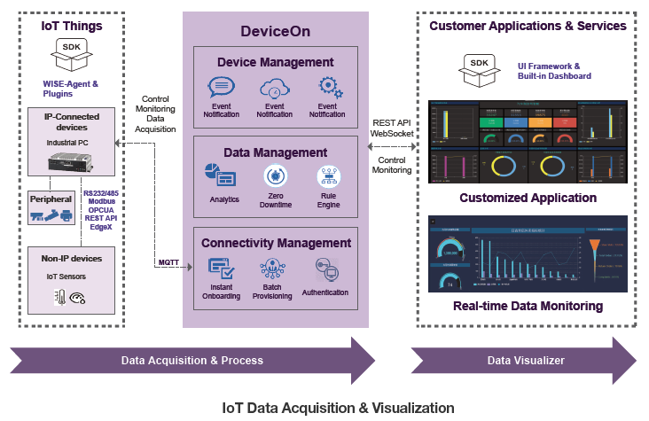

**段標：強大系統順利落地 應用案例快速浮現**

**A powerful system helps the landing of many applications**

Data Service Server 搭載WISE-PaaS/DeviceOn現已成功應用在各產業，例如在IC設計領域，某電視晶片廠就將之應用於測試設備，由於測試的時間相當長，一但過程中設備停擺，所有的程序就必須重來，因此穩定性向來是這類設備的第一要求。近期此一廠商導入研華Data Service Server與邊緣運算系統，可以統一監控現場超過200台測試設備的運作狀態，在故障前即時維修，避免出現無預警停機，另外WISE-PaaS/DeviceOn的OTA功能，可以經由遠端批量修改、更新軟體，讓廠商免去以往必須耗費大量時間，以人工方式逐台升級設備的困擾。

The Advantech Data Service Server installed with WISE-PaaS/DeviceOn is now successfully applied in many industries. For example, a TV controller SoC supplier has applied it to their test equipment. This IC maker uses over 200 computers to perform tests on TV modules at any given time; any unexpected breakdown of these test units could hitch their production efficiency. To ensure the health and reliability of these test units, this IC designer decided to deploy Advantech Data Service Server and edge computing system to implement remote and unified monitoring of all the test units in the field. On detecting abnormal signs of any equipment, the company will initiate preventive maintenance to avoid unexpected failure and downtime. The OTA function provided by WISE-PaaS/DeviceOn allows the company to remotely modify and renew programs at the edge computers in batches—over the air at once, exempting them from the previous time-consuming manual practices that they had to deal with software renewal of the field computers one by one.

第二個案例為PCB業者，此一廠商利用K8s容器化管理的優勢結合WISE-PaaS/DeviceOn二次開發，設計出貼合本身需求的烘箱管理系統。在PCB製程中，板層塗漆完成後，會將產品送入烤箱，PCB烘烤過程中，每個時間區段的溫度不同，過去烤箱溫度都由人工調控，常容易因為誤動作導致產品受損。該廠後來導入烘箱管理系統，利用其WISE-PaaS/DeviceOn OTA功能，將溫度變化腳本傳送到控制系統中，並由研華的邊緣設備執行，讓良率大幅提升。除了應用於溫度控制系統外，該PCB廠也讓WISE-PaaS/DeviceOn自動記錄現場產線的作業狀態，並製作成工單傳送到上層MES系統中，完成現場製程管理的數位化建置。也因K8s的彈性，烘箱管理系統拆解的微服務都可以因應各種產線狀況隨時調整更新。

The second application example is about a Print Circuit Board (PCB) manufacturer who took advantages from k8s containerized management technology and Advantech WISE-PaaS/DeviceOn platform in developing their own baking oven management system. Baking ovens are frequently used in PCB manufacturing as a curing process after printing, soldering or coating. The semi-finished boards are sent into an oven in batches and baked in staged temperatures, and the time and temperature for each stage of each batch differ from each other depending on required process of different product. In the past the temperature profiles are controlled manually by technicians, and a careless error in the process could result in substantial loss. Therefore, the company decided to introduce an automatic baking system, which utilizes the OTA function provided by WISE-PaaS/DeviceOn platform to allow the server to input temperature portfolios over the air into Advantech edge computers to carry out and oversee the baking process automatically. The WISE-PaaS/DeviceOn platform will also automatically record production status of each baking run and connect the data to the company’s MES system. In this way the company accomplished the digitalization of their manufacturing process management. And because of the flexibility provided by k8s technology, the micro-services for their banking system can be adjusted and renewed at any time according to their production needs.

在上述兩個案例中，IC設計業者的系統功需求能與多數廠商差別不大，因此導入了Windows 系統，PCB業者的功能特殊，系統需要二次開發，因此以Kubernetes為主。而由這兩個例子也可看出，無論是哪一類型架構，研華的Data Service Server都可滿足業界需求。對於未來發展，這兩大架構都是研華的重點發展，其中可二次開發，讓系統符合企業所需的Kubernetes，已被視為容器管理平台領域的焦點，目前各大軟硬體廠商均開始發展，研華也將持續投入研發，提供業界更完整的雲端服務平台。

In the two cases, the application requirements of the IC designer company are similar to those of most companies, so they decided to deploy Windows version of the Data Service Server; while the PCB manufacturer needed to develop their own custom functions, so they chose the Kubernetes version for more convenient development and deployment. The Kubernetes has become an apple in the eyes of enterprises pursuing containerized management platform, and many software and hardware suppliers are developing k8s-related products. Advantech as a bellwether in automation field will certainly increase development efforts in this regard to provide more powerful and complete cloud service platform to our customers.